**TECHNICAL UNIVERSITY OF MOMBASA**

**DEPERTMENT OF COMPUTER SCIENCE AND INFORMATION TECHNOLOGY**

ONLINE RECRUITMENT PORTAL

(Case Study Kakamega County)

WABUGE W KENNEDY

BSIT/034J/2014

A research project submitted to the Institute of Information and Informatics in the school for Computer Science and Information Technology in partial fulfillment of the requirement for the

Award of the degree of Bachelor of Science in Information

Technology Technical University of Mombasa.

DECEMBER, 2017

**DECLARATRION**

I WABUGE W KENEDY of Registration No. BSIT/034J/2014 Technical University of Mombasa hereby declare that this proposal is my original work and has not been presented for degree in any other University

This proposal is my original work and has not been presented /or a degree in any other University

…………………… …………………..

Signature Date.

This proposal has been submitted for examination with my approval as University Supervisor

……………………… ………………….

Signature Date.

**ABSTRACT**

In this competitive world, the education among the people is so increasing that the jobs for them are now decreasing. The companies even want the people who are best in their fields. At that time, it becomes difficult to find the people who are intelligent enough to be hired. The work for the companies also increases to find the people who can fulfill their requirements. Thinking about these problems, one can think about the process which can handle this process and make the work less complex.

This project is about the recruitment process which is done online. The recruitment process here is handled by the system. This project will allow the person to apply for a job in the company for the interested vacancy which would be available at the company. The person will be having the account after registration and will be then called the applied user. If he would be qualified, he would be notified. The project is created for fulfilling the requests of the company managers so that the recruitment module can be placed in the company’s website and the users who visit the website can view the vacancies in the company and will be able to apply directly from remote place even. The vacancies will be posted by the administrator on the basis of needs of the manpower in the company.

The admin will have all rights of handling this process except the evaluation process as it is the company specific and so the steps of the evaluation process cannot be predicted. It also includes the layers at the admin side so the privileges will have great impact on the functionalities given to the different levels of admin. The privileges will be user specific, so different admin even at same level will have different privileges and so different functionalities. The higher level admin will handle whole system by himself. Although the lower level admin is given such privileges that he can send any kind of request to the higher level admin. The higher level admin can approve or disapprove the request. Whatever the result of the request approval, the notification will be sent to the lower level admin. This project plays main role at admin side for recruitment process. The start dates and end dates for applications’ acceptance, the grace period, the job vacancies’ postings, modifying the privileges etc. are the special features of this s

# ACKNOWLEDGEMENT

I wish to acknowledge all the individuals that have helped me compile this proposal in various ways. I particularly thank my supervisor Mr. Mwangi and all the lecturers in Technical University of Mombasa who have taught me and my family for the financial support especially my brother Wabuge. I also thank my fellow students for their support and advice which made the proposal a success. Not forgetting the moral and encouragement from my wife.

**TABLE OF CONTENT**

# CHAPTER ONE.

# INTRODUCTION.

* 1. **Background information.**

Job application in KAKAMEGA COUNTY has always been a real trouble among applicants who are interested in applying for the vacancy available due to challenges to do with the human resource management and offices of respective officials and managers. It involves a lot of challenges including terrain of the COUNTY and therefore making the process tedious.

This issues prompted me to come up with a system that will help in solving this problem. In this system, an applicant is able to apply for available jobs at the comfort of their home regardless of the region of the county he/she is. After the application, the applicant should be able to get a notification, telling him/her if she has got the job or not.

* 1. **Statement of the problem.**

Job Application in KAKAMEGA COUNTY has been a difficult task over the years, it usually involves a strenuous activity getting the hardcopy form and therefore making the process long and tedious. The process is usually not transparent and sometimes the job are given based on tribes or corruptions , this is very late bad and thus applicants who are not rom the tribe of the interviewer or the managers get discouraged and are denied the job.

In this system, I am trying to bring all the processes to be transparent so that the

There will be no tribalism or corruption when giving out the jobs. It will be less tiresome and the process simple and easy and to improve transparency.

* 1. **Objectives.**
     1. **Main objectives**

To develop a system that will bring all the parameters of applying for a job into transparent, reduce the cost to hire and giving equality in all applicants.

* + 1. **Specific objectives**

1. To ensure job seekers apply for jobs available in a very simple procedure.
2. To design a system a system that will ensure transparency and equality.

And to help improve transparency in the constituency in terms of job seeking.

1. To test the system.
   1. **Justification (significance of the project).**

The project will be of great help to KAKAMEGA COUNTY, the applicants and other stakeholders Involved in job application. The completion of this project will help restore faith in the county about job placement and interview in terms of service delivery and transparency. Judging from my observation over the years, the company is in dire need of this project if they want to reduce the problems encountered in job application and interview. I therefore urge the companies’ stakeholders to embrace this project and support it.

* 1. **Scope.**
  2. **Target users.**

The users of this system are job seekers who have completed either Diploma, degree or Masters and are seeking jobs.

Also the Administrators in the COUNTY who verify the applicant’s details and approving the vacancy a pass or a fail.

# 

# 

# 

# CHAPTER 2

# LITERATURE REVIEW

**2.1 Introduction**

In today’s world technology has moved fast and we have to maintain it moving forward, so there is a need to develop new strategies to stay relevant in a changing global business environment.

A usual recruitment process seen from the organization’s viewpoint can be divided into four phases:

1. Requirements analysis

2. Publishing the job posting

3. Receiving and preselecting applications

4. Final recruitment decision.

This online is going to integrate all this steps into one module which will greatly enhance job seeking by graduate’s job seekers.

**2.2 Theoretical review**

Employee Recruitment can be defined as a practice and an activity carried on by individuals for the purpose of identifying and attracting competitive and able employees

(Bizer et al., 2005) In this study, the author says that using semantic web technologies in the domain of online recruitment could increase market transparency in job seeking. In this paper it’s describe how online recruitment processes can be streamlined using information technology.(Dias, 2001) Little is known about applicant reactions to web based and selections procedures. It was found that the features of the site perceived efficiency and friendliness to the users. (Greiner, 2004) introduces online recruitment as a convenient and efficient way of recruiting people to companies and organizations.

(De Meo, Quattrone, Terracina, & Ursino, 2007) tract—In this paper we propose an XML-based multiage recommender system for supporting online recruitment services. The paper discusses the basic features of the proposed system, presents the results of an experimental study we have carried out for evaluating its performance, and makes a comparison between the proposed system and other e-recruitment systems already presented in the past. (Mareschal & Rudin, 2011)in this study the author puts out that it’s easy to apply for a job online compared to manually.(Strohmeier, 2007) in this article the author finds out that electronic human resource has a lot of implication in the current advancing technological world. The review further reveals that employees diverse empirical methods and refers to diverse topics in e-hrm.

(Bock, Baetge, & Nicklisch, 2014)the author discuss the use of an online software for economic developments.(P & Nagi, 2017) in this study the author focuses on electronic recruitment usage of e-recruitment forms in organizations. The internet has improved the desire for online recruitment in organizations.(Greiner, 2015)here its discussed that online recruitment can help in economic developments. The software package provides a free and efficient and very strong tool to organize recruitments.(Moghaddam, Rezaei, & Amin, 2015)electronic commerce have become the key thing among competitive business organizations, therefore placing recruitment on the digital platform will be of great importance to the organisation

**2.3 System review**

The system automatically shortlisted the application forms according to years of experience, skills, and educational attainment relevant to the job vacancy. The system was able to provide sending of automated responses to qualified applicants. On the other hand, applicants could view further particulars of the post, which included background information concerning the University, faculty, department, the job description, and person specifications. They could fill out the application form online, and easily update their profiles. Sample screenshot is shown in Figure 1.



**2.4 Critique of the existing literature relevant to the study**

However, the system was not capable of doing such task as detecting errors on entered data of applicants. The system could not determine whether the data provided by the applicants were correct. Typographical errors were not detected by the system. The system could not also verify if all skills, knowledge, experience, and education specified by the users were true. Software evaluation was conducted to find out the acceptability of the software. Software evaluation was based on FURPS (Functionality, Usability, Reliability, Performance, and Security) Quality Factors [11]. Only three quality indicators (Performance, Reliability, and Security) were selected from FURPS because only these three criteria were deemed applicable in this study. Moreover, Performance and Functionality were treated as one criterion since both referred to the effective processes of the software. Lastly, Cost-effectiveness was included since it was asserted that the software could save costs to the University.

**Performance** refers to the capability of online recruitment system to generate a list of applicants suitable for the job vacancy in a quick manner. The software could facilitate efficient filtering of qualified candidates and could provide a well-matched shortlist of qualified applicants. Moreover, the system came up with recruitment policies which were free from errors and inconsistencies.

**Reliability** is the extent to which a program can be expected to perform its intended function [12]. The system could produce the required results with precision in terms of the quality of the applicant being hired for the job vacancy. It could filter out applicants’ forms without anomalies and any form of discrimination. Moreover, it provided correct results with minimum expenditure of time and effort.

**Security** is the availability of mechanisms that control or protect programs and data. It had the mechanism to protect and control programs and data, and it provided its users passwords as security against unauthorized users [12]. It was capable of securing the confidentiality of data received from different types of applicants.

**Cost-effectiveness** refers to the justification on the amount spent for the investment which commensurate with effectiveness. Online recruitment was more inexpensive compared to the other means of recruitment such as print media advertising. It could provide sufficient space to outline enough information for the candidate to understand the position and the institution

# CHAPTER 3

# ANALYSIS AND DESIGN

* 1. **Introduction**

This section elaborates the techniques that I used in the fact finding, analysis design, the design used and requirements analysis.

* 1. **Development Approach**
     1. **System design**

The section describes how the new system will function and how it is going to satisfy the user requirements of the new system. The system encompasses the design of data flow and physical design.

* + 1. **Justify the choice of your design**

The design has various advantages and this prompted me to choose it. They include:

i. Reduced cycle time and improved productivity with fewer people means lower cost.

ii. Time box approach mitigates cost and also schedule risk.

iii. The fact that customers are involved throughout the cycle helps to minimize the risk of not achieving customer’s satisfaction.

iv. Focus move from documentation to code.

v. It also uses modelling concepts to capture information about data and processes.

The methodology can also be used when:

i. The requirements are reasonably known.

ii. There is need for user’s involvement.

iii. High performance is not required.

iv. There is low technical risk.

v. The system can be modularized.

Disadvantages of RAD.

i. Depends on strong team and individual performances for identifying business requirements.

ii. High dependency on modelling skills.

iii. Required highly skilled designers.

* 1. **Fact Finding Approach**

This refers to all the processes used to collect information from applicants of the manual way of bursary application.

* + 1. **Research design**

This refers to all the processes used to collect information from applicants of the manual way of job application

* + 1. **Population**

The targeted users for this online recruitment system are job applicants who are facing difficulties in moving from one location to another looking for vacant jobs.

* + 1. **Sample and Sampling Technique**
    2. **Data collection Tools**

The data for this proposal and the system to be generated was mainly through my own experience having to go through harsh and tough job seeking procedures, I experienced the difficulties of getting employed. Other data collected for the proposal was also through observation and with this I learnt a lot. Other data collected for the proposal was also through observation and with this I learnt a lot

* 1. **Requirement Analysis**

Comprises of the user, functional and non-functional requirements

**Use requirements**

The users require a system that has the following features.

1. A user friendly graphical user interface.
2. ii. An informative and intuitive website.

**Functional requirements**

This is how the system shall look like and do when successfully completed. The system shall meet the following functional requirements:

The system shall allow job seekers to apply for jobs online. The system shall also accept only valid data to be entered into a database it shall allow registered or authorized administrators who are logged in to perform operations on the system. It will allow job seekers who have applied for the jobs to track their information (getting feedback whether granted or denied) by viewing there profiles. Only authorized administrator shall be able to add and/or delete fake profiles and a particular jobs. Shall also be able to grant/deny job vacancy to applicants. The system will also allow the applicants to register their problems and the administrator shall be able to view them and act accordingly. The system shall be able to clearly outline the requirements for a particular job.

**Non-functional Requirements**

The non-functional requirements of the system include.

The system shall display an alert reminding the user to enter valid data if he/she enters invalid data (verification). It shall also be able to run on a networked environment efficiently and effectively. The system shall also display an error massage when a user attempts to enter wrong data at logging window. It shall store data in the most efficient manner possible to keep the database from growing too big with unnecessary data.

* 1. **Logical design**

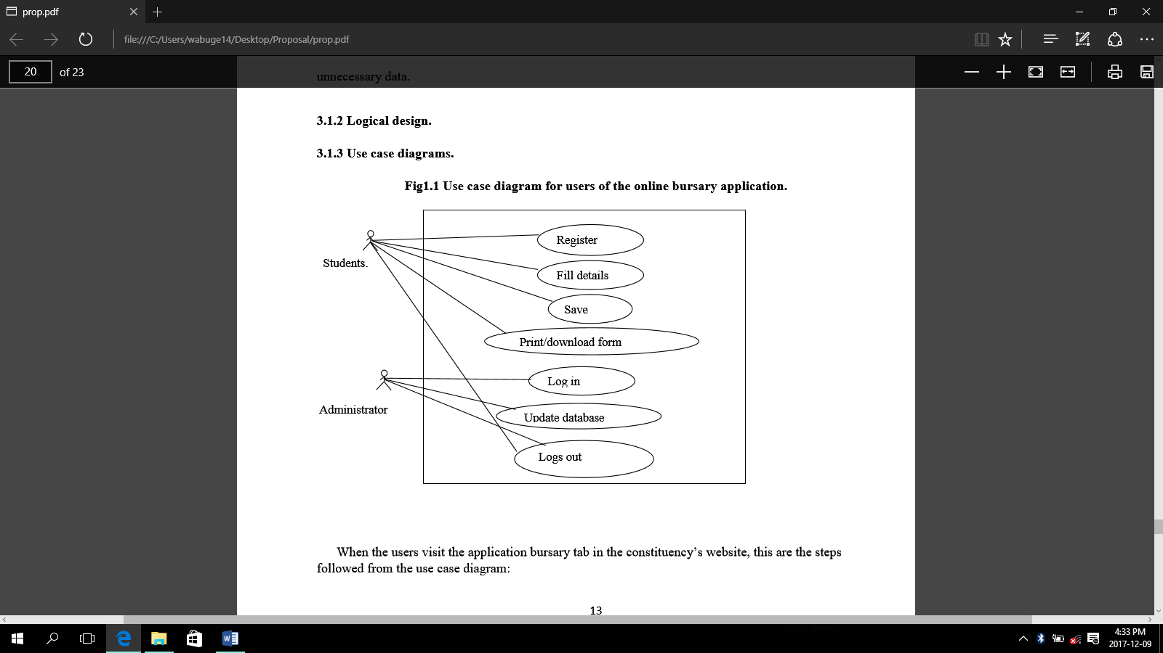

When the users visit the job application tab in the website, this are the steps followed from the use case diagram:

i. He/she registers.

ii. He/she proceeds to the applications tab and fills in the required details.

iii. After filling all the details, the applicant will be required to save details.

iv. The applicant then has the option to print or download the already filled form for stamping by the school principal or dean of students.

v. He/she then logs out.

According to the use case diagram above:

The administrator only logs in and updates the database. He then verifies the applicant’s details

* 1. **Specific platforms**
     1. **Hardware specification**

**Table 1.1 hardware specification**

|  |  |
| --- | --- |
| **Hardware** | **Minimum requirements** |
| Processor | Intel Pentium 4 , Intel Celeron |
| Hard disk siz**e** | Minimum of 320GB |
| Memory | 2GB |

* + 1. **Software specification**

***Table 1.2 software specification***

|  |  |
| --- | --- |
| Software | **Minimum system requirements** |
| Client operating systems | Windows 7and higher |
| Web server. | Apache |
| Server operating system | Windows 8 |
| Database management system | MYSQL server version |
| Web browser | Mozilla Firefox, Google chrome and Microsoft edge |
| Programming language | Php,html, css, and bootstrap |

* 1. **Summary**

**REFERENCES**

Bizer, C., Heese, R., Mochol, M., Oldakowski, R., Tolksdorf, R., & Eckstein, R. (2005). The Impact of Semantic Web Technologies on Job Recruitment Processes. In *Wirtschaftsinformatik 2005* (pp. 1367–1381). Physica, Heidelberg. https://doi.org/10.1007/3-7908-1624-8_72

Bock, O., Baetge, I., & Nicklisch, A. (2014). hroot: Hamburg Registration and Organization Online Tool. *European Economic Review*, *71*, 117–120. https://doi.org/10.1016/j.euroecorev.2014.07.003

De Meo, P., Quattrone, G., Terracina, G., & Ursino, D. (2007). An XML-based multiagent system for supporting online recruitment services. *IEEE Transactions on Systems, Man, and Cybernetics-Part A: Systems and Humans*, *37*(4), 464–480.

Dias, C. (2001). Corporate portals: a literature review of a new concept in Information Management. *International Journal of Information Management*, *21*(4), 269–287.

Greiner, B. (2004). An online recruitment system for economic experiments.

Greiner, B. (2015). Subject pool recruitment procedures: organizing experiments with ORSEE. *Journal of the Economic Science Association*, *1*(1), 114–125.

Mareschal, P. M., & Rudin, J. P. (2011). E-Government Versus E-Business: A Comparison of Online Recruitment in the Public and Private Sectors. *The American Review of Public Administration*, *41*(4), 453–467. https://doi.org/10.1177/0275074010375573

P, N. M., & Nagi, D. M. S. (2017). A Conceptual Study on E- Recruitment System and Its Efficiency in Indian MNC Companies. *Imperial Journal of Interdisciplinary Research*, *3*(8). Retrieved from http://www.imperialjournals.com/index.php/IJIR/article/view/5551

Strohmeier, S. (2007). Research in e-HRM: Review and implications. *Human Resource Management Review*, *17*(1), 19–37.